**PROJECT TITLE: FLOOD MONITORNING AND EARLY WARNING SYSTEM**

**NAME : UMA MAHESHWARI**

**COLLEGE CODE :** 9530

**Reg No :** 953021106050

**College name :** St.Mother Theresa Engineering college

**Team name :** proj 201033_ Team _1

**PROBLEM SOLUTION :**

Floods are the natural disasters that cause catastrophic destruction and devastation of natural life , agriculture ,property and infrastructure every year .The objective of this project is to monitor the flood situation and send alert in case of danger in the form of text message .The main objective of this project is to detect rising water level in a river at a reasonable distance from the rail track/roadways and intimate that to the respective authorities through SMS ,to take appropriate action .Our project solves problem by implementing an early flood detection mechanism .In this project we will connect water level sensors at different water levels.

**METHODOLGY :**

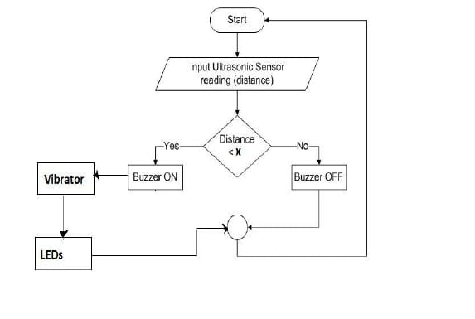

**PROBLEM ANALYSIS:**

* We don’t have system which could inform People about flood risk .
* To prevent rising or running water from causing flooding.

**PROCEDURE :**

Here the Arduino uno is connected to water float sensors & ultrasonic sensor to analyses the water level.  The ultrasonic sensors measure the distance of the water level, and the Arduino micro-controller processes the signals from the sensors. Further, these calculated values will be passed to the Arduino which is been developed with Java, C++. The Arduino would give the alert message to the IoT module.

This system used to detect the current water level of flood around the road and will give real-time information to the motorists or commuters that has still not passing through the flooded areas to avoid problem.

**COMPONENTS :**

| **S.NO.** | **COMPONENTS NAME** | **QUANTITY** |
| --- | --- | --- |
| 1. | Arduino UNO Board | 1 |
| 2. | Ultrasonic sensor | 1 |
| 3. | Buzzer | 1 |
| 4. | LED | 1 |
| 5. | Resistor | 1 |
| 6. | Connecting Jumper Wires | 10 |
| 7. | Breadboard | 1 |

**SOFTWARE :**

* **ARDUINO**

Arduino is an open-source electronics platform based on easy-to-use hardware and software. Arduino boards are able to read inputs - light on a sensor, a finger on a button, or a Twitter message - and turn it into an output - activating a motor, turning on an LED, publishing something online.